**ABES ENGINEERING COLLEGE, GHAZIABAD**

**DEPARTMENT OF ELECTRONICS**

**& COMMUNICATION ENGINEERING**



**COURSE MATERIAL**

**Subject Name:** Fundamentals of Electronics Engineering

**Subject Code:** BEC-101/201

**Branch / Semester:** All Branches / 1st or 2nd

**Session:** 2023-24 (Odd & Even-Semester)

**Faculty:** Dr. Manish Zadoo, Mr. Mudit Saxena, Ms. Pooja Pathak, Ms. Arpita Johri, Mr. Shahbaz Alam, Ms. Kavita Chaudhary & Dr. Shivam Singh

**EVALUATION - SCHEME, B.Tech- I YR./ I SEM (AKTU)**

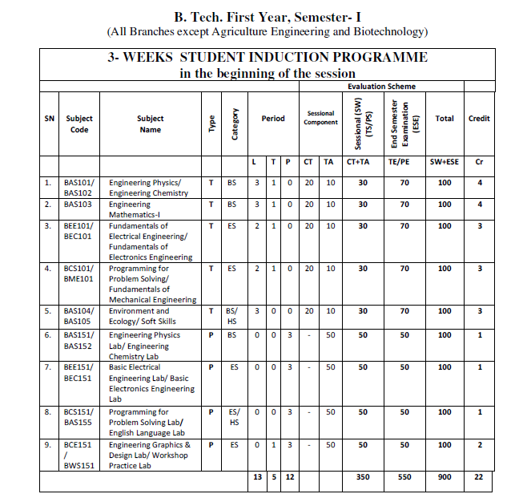

**EVALUATION - SCHEME, B.Tech- I YR./ II SEM (AKTU)**

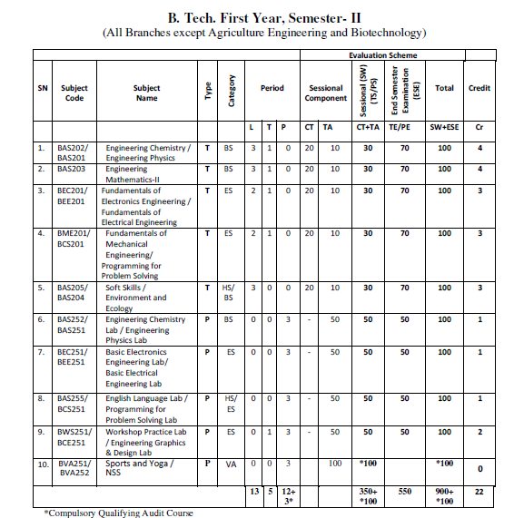

**CONTENTS AS PER SYLLABUS (UNIT-V)**

1. **Fundamentals of Communication Engineering:** 
   1. Basics of signal representation and analysis
   2. Electromagnetic spectrum
   3. Elements of a Communication System
   4. Need of modulation and typical applications
   5. Amplitude Modulation System
   6. Amplitude Modulation and Demodulation techniques
   7. DSBSC Modulation
   8. SSBSC Modulation
2. **Introduction to Wireless Communication**:

**2.1. Overview of Wireless Communication**

2.1.1. Need of Wireless Communication

2.1.2. Elements of Wireless Communication

2.1.3. Characteristics of Wireless Communication

2.1.4. Advantages of Wireless Communication

2.1.5. Disadvantages of Wireless Communication

2.1.6. Applications of Wireless Communication

**2.2. Overview of Cellular Communication**

2.2.1. Fundamentals of Cellular Communication

2.2.2. Block Diagram for Cellular Network Communication

2.2.3. Cellular Network Call Setup

**2.3. Generations of Wireless Communication**

**2.4. Overview of Satellite Communication**

2.4.1. Need of Satellite Communication

2.4.2. Block Diagram of Satellite Communication

2.4.3. Working Principle of Satellite Communication

2.4.4. Advantages of Satellite Communication

2.4.5. Limitations of Satellite Communication

2.4.6. Applications of Satellite Communication

**2.5. Overview of Radar Communication**

2.5.1. Fundamentals of RADAR Communication

2.5.2. Working Principle of RADAR Communication

2.5.3. Elements of RADAR Communication

2.5.4. Advantages of RADAR Communication

2.5.5. Limitations of RADAR Communication

2.5.6. Applications of RADAR Communication

1. **Important Questions for University Examinations**
2. **Fundamentals of Communication Engineering**
   1. **Basics of signal representation and analysis**

Signals are represented mathematically as functions of one or more independent variables. Here the focus is on involving a single independent variable.

There are two types of signals: continuous-time signals and discrete-time signals.

1. **Continuous-time signal:** The variable of time is continuous. A speech signal as a function of time is a continuous-time signal.



Figure 1.1.1: Graphical representation of Continuous-time signal

1. **Discrete-time signal:** The variable of time is discrete. The weekly stock market index is an example of discrete-time signal.



Figure 1.1.2: Graphical representation of Discrete-time signals

To distinguish between continuous-time and discrete-time signals, we use symbol t to denote the continuous variable and n to denote the discrete-time variable and for continuous-time signals, we will enclose the independent variable in parentheses (·), for discrete-time signals we will enclose the independent variable in bracket [·].

* 1. **Electromagnetic Spectrum**

The electromagnetic (EM) [spectrum](https://imagine.gsfc.nasa.gov/resources/dict_qz.html#spectrum) is the range of all types of EM [radiation](https://imagine.gsfc.nasa.gov/resources/dict_qz.html#radiation). Radiation is energy that travels and spreads out as it goes – the [visible light](https://imagine.gsfc.nasa.gov/resources/dict_qz.html#visible) that comes from a lamp in your house and the [radio](https://imagine.gsfc.nasa.gov/resources/dict_qz.html#radio) waves that come from a radio station are two types of electromagnetic radiation. The other types of EM radiation that make up the electromagnetic spectrum are [microwaves](https://imagine.gsfc.nasa.gov/resources/dict_jp.html#microwave), [infrared light](https://imagine.gsfc.nasa.gov/resources/dict_ei.html#infrared), [ultraviolet light](https://imagine.gsfc.nasa.gov/resources/dict_qz.html#ultraviolet), [X-rays](https://imagine.gsfc.nasa.gov/resources/dict_qz.html#X_ray) and [gamma-rays](https://imagine.gsfc.nasa.gov/resources/dict_ei.html#gamma_ray).

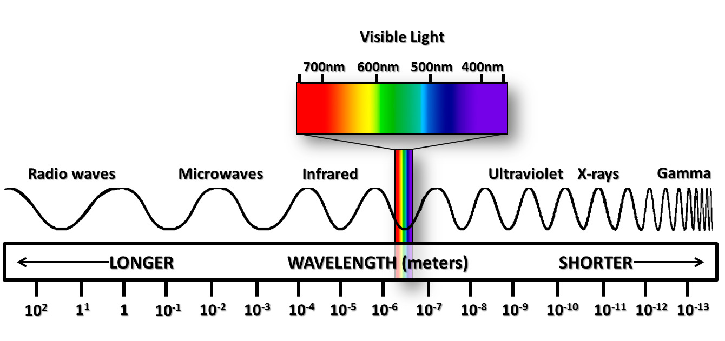

Fig.1.2. Electromagnetic Spectrum

* 1. **Elements of Communication System**

**Communication-** It is the process of transferring information from one point to another. OR It is the process of establishing connection or link between two points for information exchange.

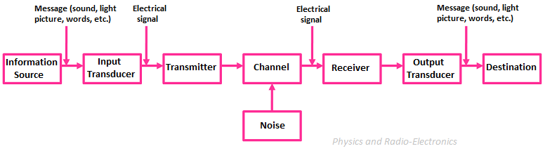

Fig.1.3. Representation of Communication System

**Elements of Communication System**

**Information source**- The message or information to be communicated originates in information source. Message can be words, group of words, code, data, symbols, signals etc.

**Input Transducer** – It will convert physical quantity (non-electrical information) into its corresponding electrical energy.

**Transmitter-** The objective of the transmitter block is to collect the incoming message signal and modify it in a suitable fashion (if needed), such that, it can be transmitted via the chosen channel to the receiving point.

**Channel**- Channel is the physical medium which connects the transmitter with that of the receiver. The physical medium includes copper wire, coaxial cable, fibre optic cable, wave guide and free space or atmosphere. Noise is added into the channel.

**Receiver**-The receiver block receives the incoming modified version of the message signal from the channel and processes it to recreate the original (non-electrical) form of the message signal.

**Output Transducer -** It will electrical energy into the corresponding original physical quantity (non-electrical information).

**Destination –** The user receives the original information.

* 1. **What is the need for modulation in communication systems?**

Modulation is a widely used process in communication systems in which a very high-frequency carrier wave is used to transmit the low-frequency message signal so that the transmitted signal continues to have all the information contained in the original message signal.

The message signals have a very low frequency due to which these signals cannot be transmitted over long distances. Hence such low-frequency message signals are modulated over the high-frequency carrier signal due to the following reasons:

1. **Practical Length of Antenna:**

For the effective transmission of a signal, the height ***h*** of the antenna should be comparable to the wavelength ***λ*** of the signal at least the height of the antenna ***h*** should be ***λ / 4***in length so that the antenna can sense the variations of the signal properly.

The low-frequency message signal has a very high value of ***λ*** which will require a very high antenna (practically not possible).

***For example:****If we have to transmit a signal of****20******kHz****then****λ = C / f****and height of the antenna****h ≈ λ****where****C****is the wave velocity, here****C = 3 × 108 m/s****.*

***h ≈ λ = (3 × 108) / (20 × 103)***

***h = 15 km.***

Hence, we need to modulate the message signal over the high-frequency carrier signal so that we can have a practical value for the height ***h*** of the antenna.

### **2.    Avoids mixing of signals**

If the baseband sound signals are transmitted without using the modulation by more than one transmitter, then all the signals will be in the same frequency range i.e. 0 to 20 kHz. Therefore, all the signals get mixed together and a receiver cannot separate them from each other.

Hence, if each baseband sound signal is used to modulate a different carrier, then they will occupy different slots in the frequency domain (different channels).  Thus, modulation avoids mixing of signals.

### **3.    Increase the Range of Communication**

The frequency of baseband signal is low, and the low frequency signals cannot travel long distance when they are transmitted. They get heavily attenuated.

The attenuation reduces with increase in frequency of the transmitted signal, and they travel longer distance. The modulation process increases the frequency of the signal to be transmitted. Therefore, it increases the range of communication.

### **4.    Multiplexing is possible**

Multiplexing is a process in which two or more signals can be transmitted over the same communication channel simultaneously. This is possible only with modulation.

The multiplexing allows the same channel to be used by many signals. Hence, many TV channels can use the same frequency range, without getting mixed with each other or different frequency signals can be transmitted at the same time.

### **5.  Improves Quality of Reception**

With frequency modulation (FM) and the digital communication techniques such as PCM, the effect of noise is reduced to a great extent. This improves quality of reception.

## Signals in the Modulation Process

Following are the three types of signals in the modulation process.

### **Message or Modulating Signal**

The signal which contains a message to be transmitted, is called as a **message signal**. It is a baseband signal, which must undergo the process of modulation, to get transmitted. Hence, it is also called as the **modulating signal**.

### **Carrier Signal**

The high frequency signal, which has a certain amplitude, frequency and phase but contains no information is called as a **carrier signal**. It is an empty signal and is used to carry the signal to the receiver after modulation.

### **Modulated Signal**

The resultant signal after the process of modulation is called as a **modulated signal**. This signal is a combination of modulating signal and carrier signal.

## Types of Modulation

There are many types of modulations. Depending upon the modulation techniques used, they are classified as shown in the following figure.

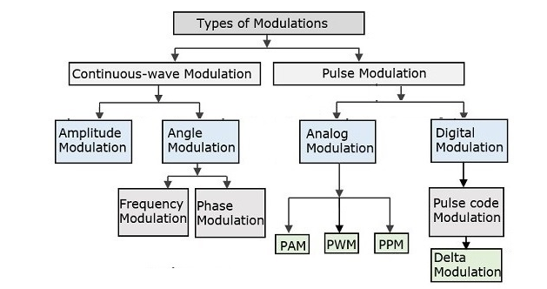

Fig.1.4. Classification of Modulation

**1.5 Amplitude Modulation Systems**

When the amplitude of the carrier is changed as according to the instantaneous value of the message/baseband signal, it results in Amplitude Modulation. The systems implanting such modulation are called as Amplitude modulation systems.

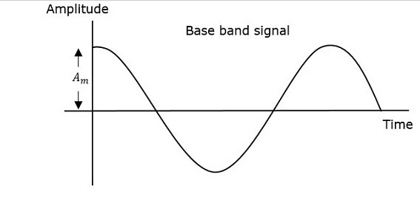

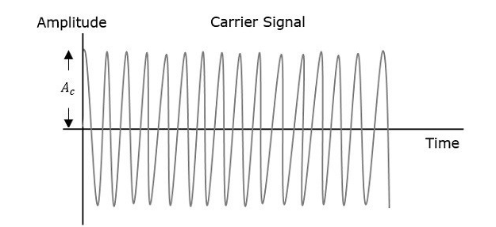

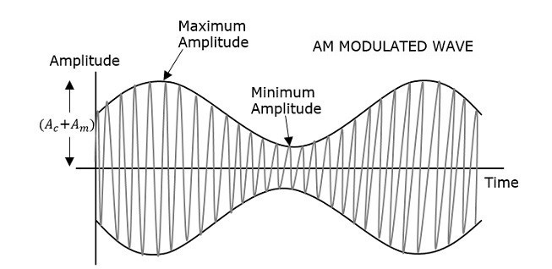

Fig.1.5.1. AM Waveforms

The first figure shows the modulating wave, which is the message signal. The next one is the carrier wave, which is a high frequency signal and contains no information. While the last one is the resultant modulated wave.

It can be observed that the positive and negative peaks of the carrier wave, are interconnected with an imaginary line. This line helps recreating the exact shape of the modulating signal. This imaginary line on the carrier wave is called as **Envelope**. It is the same as that of the message signal.

## Mathematical Expressions

Following are the mathematical expressions for these waves.

### **Time-domain Representation of the Waves**

Let the modulating signal be,

m(t) = Am cos(2πfmt)

and the carrier signal be,

c(t) = Ac cos(2πfct)

Where,

Am and Ac are the amplitude of the modulating signal and the carrier signal respectively.

fm and fc are the frequency of the modulating signal and the carrier signal respectively.

Then, the equation of Amplitude Modulated wave will be

s(t) = [Ac + Am cos(2πfmt)] cos(2πfct) (1)

## Modulation Index

A carrier wave, after being modulated, if the modulated level is calculated, then such an attempt is called as **Modulation Index** or **Modulation Depth**. It states the level of modulation that a carrier wave undergoes.

Rearrange the Equation 1 as below.

$s\left(t\right)=Ac\left[1+\left(\frac{Ac}{Am}\right)\cos\left(2πfmt\right)\right]cos⁡(2πfct)$ (2)

$s\left(t\right)=Ac\left[1+μ\cos\left(2πfmt\right)\right]cos⁡(2πfct)$ (3)

Where μ is the modulation index and is the ratio of Am and Ac.

Hence, we can calculate the value of modulation index by using the above formula, when the amplitudes of the message and carrier signals are known.

Now, let us derive one more formula for Modulation index by considering Equation 1. We can use this formula for calculating modulation index value, when the maximum and minimum amplitudes of the modulated wave are known.

Let Amax and Amin be the maximum and minimum amplitudes of the modulated wave.

We will get the maximum amplitude of the modulated wave, when cos($2πfmt)$ is 1

Amax = Ac + Am (4)

We will get the minimum amplitude of the modulated wave, when cos(2*πfmt*) is -1

Amin = Ac - Am (5)

Add Equation 4 and Equation 5

Amax  +Amin = Ac + Am + Ac - Am = 2 Am

Am  = (Amax  +Amin)/2 (6)

The ratio of Equation 6 and Equation 5 will be as follows

$\frac{Am}{Ac}=\frac{\frac{Amax-Amin}{2}}{(Amax+Amin)/2}$

μ= $\frac{Am}{Ac}=\frac{\frac{Amax-Amin}{2}}{(Amax+Amin)/2}$

Therefore, Equation 3 and Equation 8 are the two formulas for Modulation index. The modulation index or modulation depth is often denoted in percentage called as Percentage of Modulation. We will get the **percentage of modulation**, just by multiplying the modulation index value with 100.

For a perfect modulation, the value of modulation index should be 1, which implies the percentage of modulation should be 100%.

For instance, if this value is less than 1, i.e., the modulation index is 0.5, then the modulated output would look like the following figure. It is called as **Under-modulation**. Such a wave is called as an **under-modulated wave**.

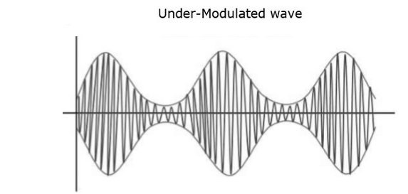

Fig.1.5.2. Under modulated AM Wave

If the value of the modulation index is greater than 1, i.e., 1.5 or so, then the wave will be an **over-modulated wave**. It would look like the following figure.

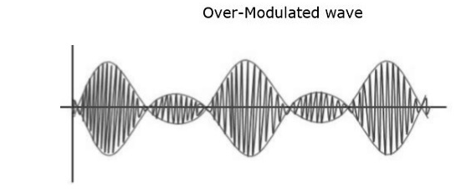

Fig.1.5.3. Over modulated AM Wave

As the value of the modulation index increases, the carrier experiences a 180o phase reversal, which causes additional sidebands and hence, the wave gets distorted. Such an over-modulated wave causes interference, which cannot be eliminated.

## Bandwidth of AM Wave

**Bandwidth** (BW) is the difference between the highest and lowest frequencies of the signal. Mathematically, we can write it as

BW = fmax - fmin

Consider the following equation of amplitude modulated wave.

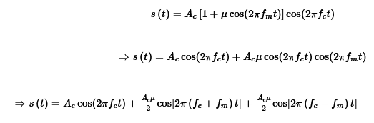

Hence, the amplitude modulated wave has three frequencies. Those are carrier frequency *fc*, upper sideband frequency *fc*+*fm* and lower sideband frequency *fc*−*fm*

Here,

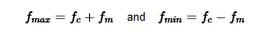

Substitute, *fmax* and *fmin* values in bandwidth formula.

*BW*=*fc*+*fm*−(*fc*−*fm*)

*BW*=2*fm*

Thus, it can be said that the bandwidth required for amplitude modulated wave is twice the frequency of the modulating signal.

## Power Calculations of AM Wave

Consider the following equation of amplitude modulated wave.

*s*(*t*)=*Ac*cos(2*πfct*)+*Acμ*2cos[2*π*(*fc*+*fm*)*t*]+*Acμ*2cos[2*π*(*fc*−*fm*)*t*]

Power of AM wave is equal to the sum of powers of carrier, upper sideband, and lower sideband frequency components.

*Pt*=*Pc*+*PUSB*+*PLSB*

We know that the standard formula for power of cos signal is

*P* = *vrms*2*/R* = (*vm*/√2)2/2

where,

*Vrms* is the rms value of cos signal.

*Vm* is the peak value of cos signal.

First, let us find the powers of the carrier, the upper and lower sideband one by one.

Carrier power

*Pc* = (*Ac*/√2)2/*R* = *Ac*2/2*R*

Upper sideband power

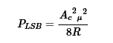

Now, let us add these three powers in order to get the power of AM wave.

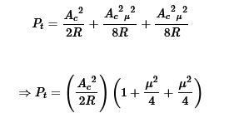

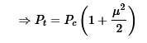

We can use the above formula to calculate the power of AM wave, when the carrier power and the modulation index are known.

If the modulation index *μ*=1

then the power of AM wave is equal to 1.5 times the carrier power. So, the power required for transmitting an AM wave is 1.5 times the carrier power for a perfect modulation.

**1.6. AM Modulation & Demodulation Techniques**

**1.6.1 AM Modulators**

## Square Law Modulator

## Following is the block diagram of the square law modulator

## 

## Fig;1.6.1 Square Law AM Modulator

## Let the modulating and carrier signals be denoted as *m*(*t*) and *A*cos(2*πfct*) respectively. These two signals are applied as inputs to the summer (adder) block. This summer block produces an output, which is the addition of the modulating and the carrier signal. Mathematically, we can write it as

## 

## This signal V1t is applied as an input to a nonlinear device like diode. The characteristics of the diode are closely related to square law.



Where, *k*1 and *k*2 are constants.

Substitute *V*1(*t*) in Equation

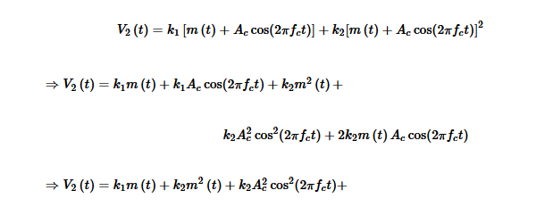

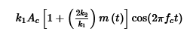

The last term of the above equation represents the desired AM wave and the first three terms of the above equation are unwanted. So, with the help of band pass filter, we can pass only AM wave and eliminate the first three terms.

Therefore, the output of square law modulator is

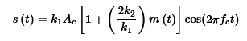

The standard equation of AM wave is



Where, *Ka*

is the amplitude sensitivity

By comparing the output of the square law modulator with the standard equation of AM wave, we will get the scaling factor as *k*1

and the amplitude sensitivity *ka* as 2*k*2*k*1

**1.6.2. AM Demodulator**

Square law demodulator is used to demodulate low level AM wave. Following is the block diagram of the **square law demodulator**.

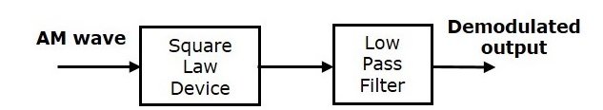

## Fig;1.6.2. AM Square Law Demodulator

This demodulator contains a square law device and low pass filter. The AM wave *V*1(*t*)

is applied as an input to this demodulator.

The standard form of AM wave is

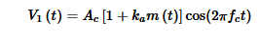

We know that the mathematical relationship between the input and the output of square law device is



Where, *V*1(*t*) is the input of the square law device, which is nothing but the AM wave

*V*2(*t*) is the output of the square law device

*k*1 and *k*2are constants

Substitute *V*1(*t*) in Equation 1

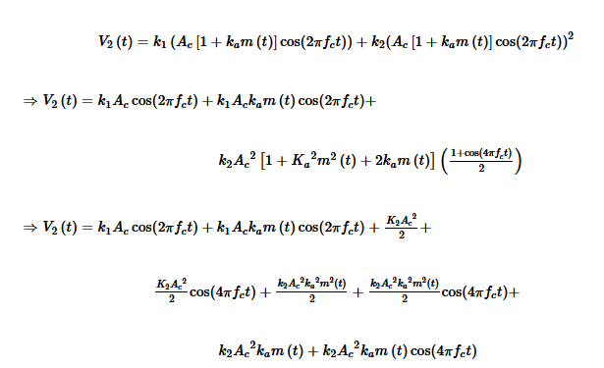

In the above equation, the term *k*2*Ac*2*kam*(*t*) is the scaled version of the message signal. It can be extracted by passing the above signal through a low pass filter and the DC component *k*2*Ac*2/2 can be eliminated with the help of a coupling capacitor.

## Envelope Detector

Envelope detector is used to detect (demodulate) high level AM wave. Following is the block diagram of the envelope detector.

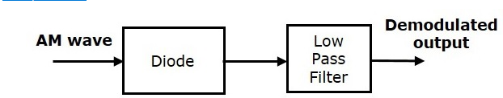

## Fig;1.6.3. Envelope Detector

This envelope detector consists of a diode and low pass filter. Here, the diode is the main detecting element. Hence, the envelope detector is also called as the **diode detector**. The low pass filter contains a parallel combination of the resistor and the capacitor.

The AM wave *s*(*t*) is applied as an input to this detector.

We know the standard form of AM wave is

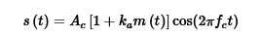

In the positive half cycle of AM wave, the diode conducts and the capacitor charges to the peak value of AM wave. When the value of AM wave is less than this value, the diode will be reverse biased. Thus, the capacitor will discharge through resistor **R** till the next positive half cycle of AM wave. When the value of AM wave is greater than the capacitor voltage, the diode conducts and the process will be repeated.

We should select the component values in such a way that the capacitor charges very quickly and discharges very slowly. As a result, we will get the capacitor voltage waveform same as that of the envelope of AM wave, which is almost similar to the modulating signal.

**1.7. DSBSC Modulation**

Here, the modulated wave has the information only in the sidebands. **Sideband** is a band of frequencies, containing power, which are the lower and higher frequencies of the carrier frequency.

The transmission of a signal, which contains a carrier along with two sidebands can be termed as **Double Sideband Full Carrier** system or simply **DSBFC**. It is plotted as shown in the following figure.

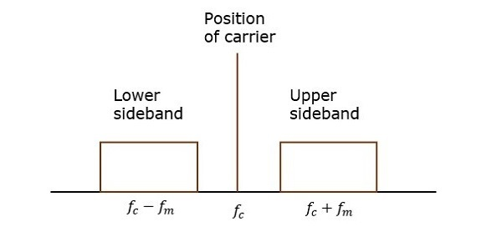

## Fig;1.7.1. AM Power Spetrum

However, such a transmission is inefficient. Because, two-thirds of the power is being wasted in the carrier, which carries no information.

If this carrier is suppressed and the saved power is distributed to the two sidebands, then such a process is called as **Double Sideband Suppressed Carrier** system or simply **DSBSC**. It is plotted as shown in the following figure.

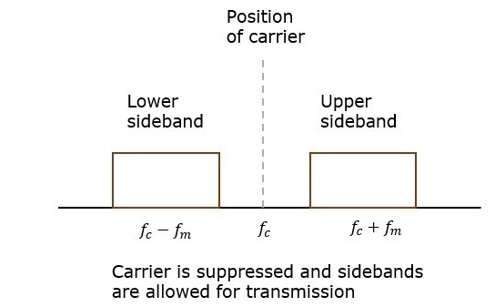

## Fig;1.7.2. DSBSC Power Spectrum

**Power for DSBSC Wave**

$P_{T}$ = $P_{c}$. $\frac{m^{2}}{2}$

**1.8. SSBSC Modulation**

The process of suppressing one of the sidebands along with the carrier and transmitting a single sideband is called as **Single Sideband Suppressed Carrier** system or simply **SSBSC**. It is plotted as shown in the following figure.

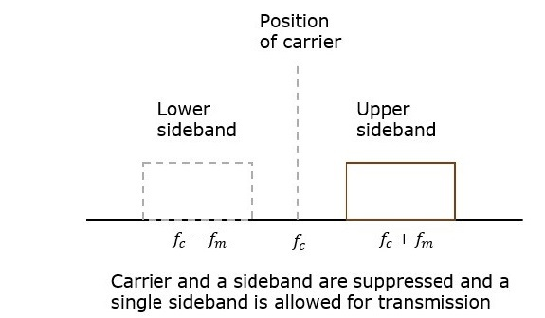

## Fig. 1.8. SSBSC Power Spectrum

In the above figure, the carrier and the lower sideband are suppressed. Hence, the upper sideband is used for transmission. Similarly, we can suppress the carrier and the upper sideband while transmitting the lower sideband.

This SSBSC system, which transmits a single sideband has high power, as the power allotted for both the carrier and the other sideband is utilized in transmitting this Single Sideband.

## Power for SSBSC Wave

$P_{T}$ = $P_{c}$. $\frac{m^{2}}{4}$

### **Advantages of SSBSC**

* Bandwidth or spectrum space occupied is lesser than AM and DSBSC waves.
* Transmission of more number of signals is allowed.
* Power is saved.
* High power signal can be transmitted.
* Less amount of noise is present.
* Signal fading is less likely to occur.

### **Disadvantages of SSBSC**

* The generation and detection of SSBSC wave is a complex process.
* The quality of the signal gets affected unless the SSB transmitter and receiver have an excellent frequency stability.

### **Applications of SSBSC**

* For power saving requirements and low bandwidth requirements.
* In land, air, and maritime mobile communications.
* In point-to-point communications.
* In radio communications.
* In television, telemetry, and radar communications.
* In military communications, such as amateur radio, etc.

**2. Introduction to Wireless Communication**

**2.1. Overview of Wireless Communication**

* Wireless communication is the fastest-growing field of communications in which information is transmitted from one place to another without any connection like wires or any physical medium between the two communicating nodes.
* In wireless communication the transmitter and the receiver can be placed anywhere between a few meters like TV remote control to few thousand km like satellite communication.
* Even though there is no physical connection in the wireless communication the transmission and the reception of data signal are done through an antenna.
* Antennas are devices that transform electrical signals to electromagnetic (EM) waves that propagate to space. EM waves are used in wireless communication to carry signals.
* EM waves include X-rays microwave radio waves etc. They consist of both electric and magnetic fields in the form of time-varying sinusoidal.

**2.1.1. Need for Wireless Communication**

When wired communication can do most of the tasks that a wireless communication can, why do we need Wireless Communication? The primary and important need of wireless communication is mobility.

* Apart from mobility, wireless communication also offers flexibility and ease of use, which makes it increasingly popular day by day.
* Wireless Communication like mobile telephony can be made anywhere and anytime with a considerably high throughput performance.
* Another important point is infrastructure. The setup and installation of infrastructure for wired communication systems is an expensive and time-consuming job. The infrastructure for wireless communication can be installed easily and low cost.
* In emergency situations and remote locations, where the setup of wired communication is difficult, wireless communication is a viable option.

### **Basic Elements of a Wireless Communication System**

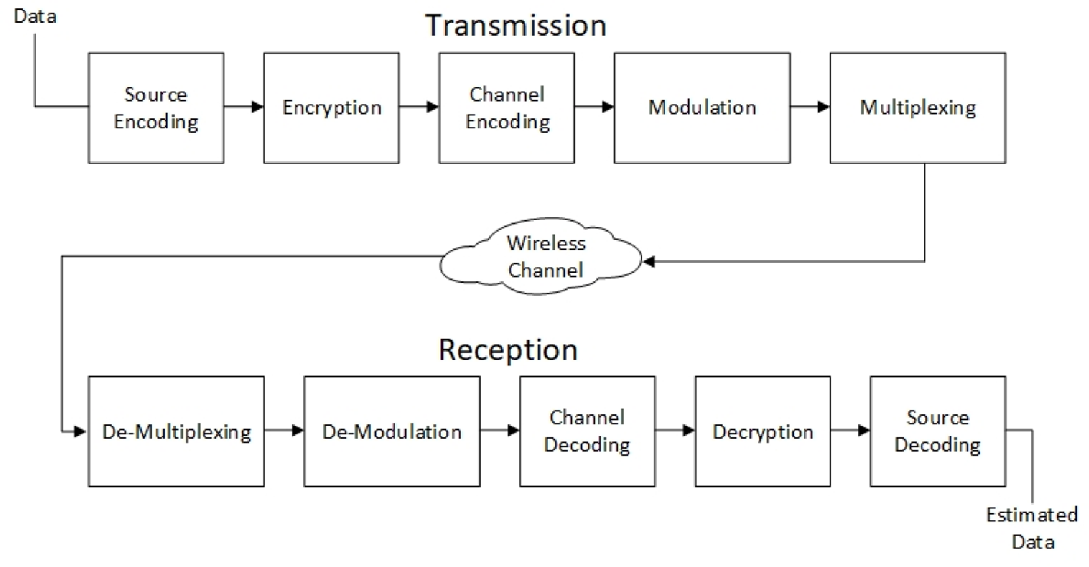

Fig**.** 2.1. Block Diagram of Wireless Communication System

* **The source encoder** converts the signal into a suitable form for signal processing techniques. Redundant information is removed in order to maximize the utilization of the resources.
* **Encryption** is done to make information secure so that it cannot be accessed by be any unauthorized user.
* **Channel coding** is done to reduce the distortion and impairments like noise it is done by adding a small amount to make signal robot against noise.
* **Modulation** is done so that the signal can easily be transmitted through an antenna
* Modulated signal is **multiplexed** with other signals to share the bandwidth.
* Open space is used as the channel to transmit signal.  A channel may be subject to interference, distortion, noise, scattering etc. and the result is that the received signal may be filled with errors.
* The function of the receiver is to collect the signal from the channel and reproduce it as the source signal. The reception path of a Wireless Communication System comprises of Demultiplexing, Demodulation, Channel Decoding, Decryption, and Source Decoding
* The signal from the channel is received by the **Demultiplexer** and is separated from other signals.
* The individual signals are **demodulated** using appropriate Demodulation Techniques and the original message signal is recovered.
* The redundant bits from the message are removed using the **Channel Decoder**.
* Since the message is encrypted, **decryption** of the signal removes the security and turns it into a simple sequence of bits.
* Finally, this signal is given to the **Source Decoder** to get back the original transmitted message or signal.

**2.1.3. Characteristics of Wireless Communication**

Wireless communication links have several special characteristics that differentiate them from wired communication links. These characteristics include:

1. **Mobility**: Wireless communication links allow for mobile communication, where the user can move around freely while staying connected to the network. This is especially useful in situations where mobility is required, such as in a car or on a mobile device.
2. **Flexibility**: Wireless communication links are flexible and can be used in a variety of environments, including indoors and outdoors, in rural or urban areas, and in remote locations.
3. **Scalability**: Wireless communication links can be easily scaled up or down to accommodate changes in demand. This makes them ideal for situations where the demand for communication services may fluctuate over time.
4. **Accessibility**: Wireless communication links can provide access to communication services in areas where wired communication links are not available or feasible. This is particularly important in rural or remote areas, where wired infrastructure may be limited.
5. **Interference**: Wireless communication links are susceptible to interference from other wireless signals and noise, which can affect their performance. This requires careful management of the wireless spectrum to ensure that different wireless networks can coexist without interfering with each other.
6. **Security**: Wireless communication links require special security measures to protect against eavesdropping and other security threats. This includes encryption of data and authentication of users to prevent unauthorized access to the network.

**2.1.4. Advantages of Wireless Communication**

Following are the advantages of wireless communication system:

* **Cost-effective:** The cost of installing wire cable and other infrastructure has been eliminated in wireless communication and lowering the oral cost of the system
* **Speed:** Improvements can also be seen in speed. The network connectivity or accessibility was much improved in accuracy and speed.
* **Mobility**: It is the freedom to move around while still connecting to the network
* **Ease of installation**: The time required to set up a wireless system such as Wi-Fi is very less and processes easy as compared to the full cable network.
* **Reliability**: As there is no cable in the wireless system there is no chance of communication failure due to damage of cables.
* **Disaster Recovery**: The loss of the communication infrastructure in wireless communication is minimal in case of accident due to fire flood and other disaster.
  + 1. **Disadvantages of Wireless Communication**

The following are the disadvantages of wireless communication systems:

* **Interference:** As open space is used as a medium in wireless communication there are huge chances of interference of radio signals with one another
* **Security**: As signals are transmitted in open space it is possible that intruders can intercept the signal to copy sensitive information
* **Health Concern**s: Continuous exposure to any radiation can be hazardous though the level of RF energy that can cause damage is not accurately established but it is advised to avoid exposure to radiation.

**2.1.6. Application of Wireless Communication**

Here are some applications of wireless communication:

* **Mobile communications:** We use things like cell phones and satellites to talk and send messages over long distances.
* **Internet of Things (IoT):** This is when we connect different gadgets over the internet, like innovative home products and industrial machines.
* **Wireless Sensor Networks (WSNs):** These tiny sensors can gather information like temperature and pressure and send it to a central system. We use them for things like traffic management and environmental monitoring.
* **Satellite communication:** We use satellites to send and get information, like weather forecasting and TV broadcasting.
* **Wireless local area networks:** This is when we connect devices to the internet without wires, like in our homes or public places like airports.
* **Wireless power transfer (WPT):** We send electrical power without cords, which we use in medical equipment and electric cars.
  1. **Cellular Communication**
* The cellular network is a fundamental technology for mobile phones, personal communication systems, wireless networking, etc.
* The technology is planned to replace high-power transmitter/receiver systems for cell radio phones. For data transmission, cellular networks use lower capacity, shorter range, and more transmitters.
* It is not a complete wireless technology because the cellular network refers to a large area of mobile networks that is used for network access. A mobile device is linked to its base station using an air-based interface and also using a physical and link layer protocol.
* Every base station is connected to the Mobile Switching Centre to help set up a call and mobility network by connecting mobile phones to wide area networks. Whereas devices used in wireless networks are used to access the internet.
* Cellular networks rely on the availability of network ranges and Wi-Fi has a limited range.

**2.2.1. Key points about cellular communication**:

* **Network Infrastructure**: Cellular communication relies on a network of cell towers and base stations that are strategically placed to provide coverage over a specific geographic area. These towers are interconnected and connected to a central switching system.
* **Wireless Communication**: Unlike traditional landline telephones, cellular communication is wireless, meaning it does not require physical connections between the device and the network infrastructure. Signals are transmitted over the air using radio waves.
* **Mobile Devices**: Mobile devices, including smartphones, feature cellular radios that allow them to connect to the nearest cell tower. They have Subscriber Identity Module (SIM) cards that identify and authenticate the user on the network.
* **Frequency Bands**: Cellular networks use specific frequency bands allocated by regulatory authorities. Different regions and countries may use different frequency bands and standards, such as GSM, CDMA, or LTE for their cellular networks.
* **Voice and Data**: Cellular communication supports both voice and data services. Voice calls are typically carried using circuit-switching technology, while data services, including internet access, use packet-switching technology.
* **Roaming**: Cellular networks often have roaming agreements with other providers, allowing users to maintain connectivity when traveling outside their home network's coverage area. Roaming involves the use of partner networks while preserving the user's phone number and services.
* **Generations of Technology**: Cellular communication has evolved through different generations, including 2G (2nd Generation), 3G (3rd Generation), 4G (4th Generation), and 5G (5th Generation). Each generation has brought improvements in terms of speed, capacity, and capabilities.
* **Security**: Cellular communication networks incorporate various security measures to protect user data and privacy. Encryption, authentication, and authorization mechanisms are used to ensure secure communication.
* **Data Plans**: To access data services on cellular networks, users typically subscribe to data plans offered by their service providers. These plans specify the amount of data, text messages, and voice minutes included, often with different pricing tiers.

**2.2.2 Block Diagram for Cellular Network Communication**

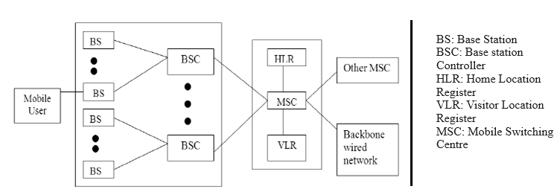

Fig**.** 2.2. Block Diagram for Cellular Network Communication

**2.2.3 Cellular Network Call Setup:**

Call setup in cellular communication involves a series of steps to establish a connection between two parties for a voice call. Here are the key steps involved in setting up a call-in cellular communication:

1. **Initiation:** The call setup process begins when a user initiates a call on their mobile device by dialing a phone number or selecting a contact.
2. **Cell Tower Selection**: The mobile device scans for nearby cell towers (BS) and selects the one with the strongest signal. This tower will be used to establish the call.
3. **Authentication**: The mobile device sends a request to the selected cell tower, which includes information about the call request and the user's SIM card details. The network verifies the SIM card's authenticity and user authorization.
4. **Call Request Forwarding:** After authentication, the cell tower forwards the call request to the cellular network's Mobile Switching Centre (MSC) or central switching system.
5. **Call Routing:** The MSC determines the destination of the call based on the dialled phone number. It communicates with the Home Location Register (HLR) to retrieve routing information for the recipient's device.
6. **Location Update:** If the recipient's device is not within the coverage area of the same cell tower, the HLR provides information on the recipient's current location. The MSC initiates the call setup procedure in the appropriate cell tower or switch in that area.
7. **Forwarding to Destination Cell Tower:** If necessary, the call request is forwarded to the cell tower serving the recipient's location.
8. **Ringing:** The recipient's device is alerted, and it starts ringing to indicate an incoming call. The user may choose to answer or reject the call.
9. **Call Establishment:** When the recipient accepts the call, a dedicated circuit-switched connection is established between the two devices. This connection is reserved exclusively for the duration of the call.
10. **Voice Communication:** Once the call is connected, voice data is transmitted between the two devices over the dedicated circuit-switched connection. This ensures real-time voice communication.
11. **Quality of Service (QoS):** Throughout the call, the network monitors and manages the Quality of Service (QoS) to ensure that the call quality is acceptable. Adjustments may be made to optimize voice clarity and minimize disruptions.
12. **Call Termination:** When either party decides to end the call or presses the "end call" button on their device, a signal is sent to the network to terminate the dedicated connection.
13. **Resource Release:** The network releases the allocated resources, including the dedicated circuit-switched connection and bandwidth, back to the pool for other users.
14. **Billing:** The network logs the call duration and details for billing purposes, generating records that will be used to calculate the charges for the call.
15. **End of Call:** The call is officially concluded, and both devices return to standby mode, ready for future calls or data usage.

# **2.3 Generations of Wireless Communication**

Over the most recent couple of decades, there has been a huge progression in mobile wireless communications. Mobile Communication systems have encountered an astounding change. It started with 1G technology of which in a very short amount of time got superseded by 2G, 3G, 4G, & now even 5G.

Mobile telecommunications has turned out to be more mainstream in the most recent couple of years because of a quick change from 1G to 5G in portable innovation and how we use technology today. This change is because of the necessity of perfect transmission innovation and high increment in telecoms clients for everyday uses including businesses, the education sector, and just about every other industry.

Here is an overview of the key stages in the evolution of mobile communication:

**1G (First Generation):**

* Introduced in the 1980s.
* Analog technology.
* Limited voice communication.
* Large and bulky devices.
* Limited coverage and security.

**2G (Second Generation):**

* Introduced in the early 1990s.
* Digital technology (e.g., GSM and CDMA).
* Improved voice quality.
* Introduction of SMS (Short Message Service).
* Enhanced security and encryption.
* Smaller and more portable devices.

**2.5G (2.5 Generation):**

* An intermediate step between 2G and 3G.
* Improved data services (e.g., GPRS and EDGE).
* Basic internet access.
* Faster data transfer compared to 2G.

**3G (Third Generation):**

* Introduced in the early 2000s.
* High-speed data transmission.
* Video calling and mobile internet.
* Enhanced multimedia capabilities.
* Improved network capacity and efficiency.

**3.5G and 3.75G:**

* Evolutions of 3G technology.
* Even faster data speeds.
* Improved support for video streaming and online gaming.
* Advanced network technologies.

**4G (Fourth Generation):**

* Introduced in the late 2000s.
* Ultra-fast data speeds (up to 100 Mbps).
* Low latency and improved network reliability.
* Enabling technologies for mobile apps, video streaming, and VoIP services.
* High-definition voice calls (VoLTE) & advanced network infrastructure (e.g., LTE).
* Gigabit-level data speeds.

**5G (Fifth Generation):**

* Began rolling out in the late 2010s.
* Ultra-high-speed data (multi-gigabit) and low latency.
* Massive IoT connectivity.
* Network slicing for customized services.
* Support for augmented reality (AR), virtual reality (VR), and autonomous vehicles.
* As technology continues to advance, future generations of mobile communication are expected to bring even more transformative changes to our connected world.

**2.4. Fundamentals of Satellite Communication**

* In general terms, a **satellite** is a smaller object that revolves around a larger object in space. For example, the moon is a natural satellite of Earth.
* If the communication takes place between any two earth stations through a satellite, then it is called **satellite communication**.
* In this communication, electromagnetic waves are used as carrier signals. These signals carry information such as voice, audio, video, or any other data between ground and space and vice-versa.
* The Soviet Union launched the world's first artificial satellite, Sputnik 1 in 1957. Nearly 18 years, India also launched the artificial satellite named, Aryabhata in 1975.

## 2.4.1. Need of Satellite Communication

The following two kinds of propagation are used earlier for communication up to some distance.

* **Ground wave propagation** − Ground wave propagation is suitable for frequencies up to 30MHz. This method of communication makes use of the troposphere conditions of the earth.
* **Sky wave propagation** − The suitable bandwidth for this type of communication is broadly between 30–40 MHz and it makes use of the ionosphere properties of the earth.

## The maximum hop or station distance is limited to 1500 km only in both ground wave propagation and sky wave propagation. Satellite communication overcomes this limitation. In this method, satellites provide communication for long distances, which is well beyond the line of sight. Since the satellites are located at a certain height above the earth, communication takes place between any two earth stations easily via satellite. So, it overcomes the limitation of communication between two earth stations due to the earth’s curvature.

**2.4.2 Block Diagram of Satellite Communication**

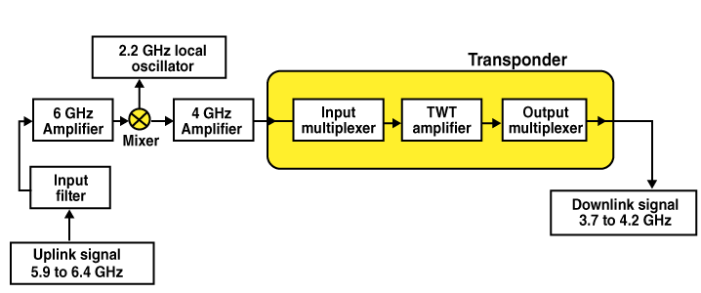

Fig**.** 2.4.1. Block Diagram of Satellite Communication

## 2.4.3. How does Satellite Communications work?

The communication satellites are similar to the space mirrors that help us bounce signals such as radio, internet data, and television from one side of the earth to another. Three stages are involved, which explain the working of satellite communications. These are:

* Uplink
* Transponders
* Downlink
* Let’s consider an example of signals from a television. In the first stage, the signal from the television broadcast on the other side of the earth is first beamed up to the satellite from the ground station on the earth. This process is known as **uplink**. The frequency with which, the signal is sent into the space is called **Uplink frequency**.
* The second stage involves transponders such as radio receivers, amplifiers, and transmitters. These transponders boost the incoming signal and change its frequency so that the outgoing signals are not altered. Depending on the incoming signal sources, the transponders vary.
* The final stage involves a **downlink** in which the data is sent to the other end of the receiver on the earth. The frequency with which, the signal is sent by the transponder is called **Downlink frequency**. It is important to understand that usually, there is one uplink and multiple downlinks.

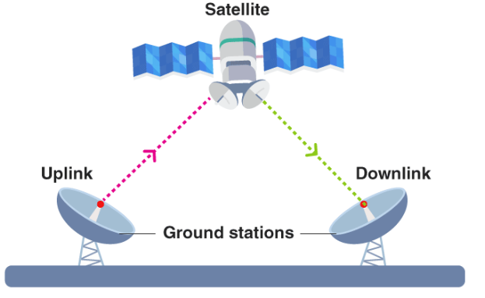

Fig**.** 2.4.2. Communication between two ground stations using Satellite

**2.4.4 Advantages of Satellite Communication**

The following are the advantages of satellite communication:

* Area of coverage is more than that of terrestrial systems
* Each and every corner of the earth can be covered
* Transmission cost is independent of coverage area
* More bandwidth and broadcasting possibilities

## Limitations of Satellite Communication

The following are the disadvantages of satellite communication:

* Launching of satellites into orbits is a costly process.
* The propagation delay of satellite systems is more than that of conventional terrestrial systems.
* Difficult to provide repair activities if any problem occurs in a satellite system.
* Free space loss is more
* There can be congestion of frequencies.

## 2.4.6 Applications of Satellite Communication

The following are the applications of satellite communication:

* Radio broadcasting and voice communications
* TV broadcasting such as Direct To Home (DTH)
* Internet applications such as providing Internet connection for data transfer, GPS applications, Internet surfing, etc.
* Military applications and navigations
* Remote sensing applications
* Weather condition monitoring & Forecasting.

# **Fundamentals of RADAR communication**

RADAR is an electromagnetic-based detection system that works by radiating electromagnetic waves and then studying the echo or the reflected back waves.

The full form of **RADAR** is **RA**dio **D**etection **A**nd **R**anging. Detection refers to whether the target is present or not. The target can be stationary or movable, i.e., non-stationary. Ranging refers to the distance between the Radar and the target.

**2.5.1. Fundamentals of RADAR**

* The RADAR system generally consists of a transmitter that produces an electromagnetic signal that is radiated into space by an antenna.
* When this signal strikes an object, it gets reflected or reradiated in many directions. This reflected or echo signal is received by the radar antenna which delivers it to the receiver, where it is processed to determine the geographical statistics of the object.
* The range is determined by calculating the time taken by the signal to travel from the RADAR to the target and back. The target’s location is measured in angle, from the direction of the maximum amplitude echo signal, the antenna points to.
* To measure the range and location of moving objects, the Doppler Effect is used. Generally, it works in the microwave area of the electromagnetic spectrum that is calculated in hertz when frequencies extend from 400 MHz to 40 GHz.

**2.5.2. Working Principle of RADAR**

The radar working principleis very simple because it transmits electromagnetic power as well as examines the energy returned to the target. If the returned signals are received again at the position of their source, then an obstacle is in the transmission way.

**2.5.3. Elements of RADAR system**

**A Transmitter:** It can be a power amplifier like a Klystron, Travelling Wave Tube, or a power Oscillator like a Magnetron. The signal is first generated using a waveform generator and then amplified in the power amplifier.

* **Waveguides:** The waveguides are transmission lines for transmission of the RADAR signals.
* **Antenna:** The antenna used can be a parabolic reflector, planar array, or electronically steered phased array.
* **Duplexer:** A duplexer allows the antenna to be used as a transmitter or a receiver. It can be a gaseous device that would produce a short circuit at the input to the receiver when the transmitter is working.
* **Receiver:** It can be a superheterodyne receiver or any other receiver that consists of a processor to process the signal and detect it.
* **Threshold Decision:** The output of the receiver is compared with a threshold to detect the presence of any object. If the output is below any threshold, the presence of noise is assumed.

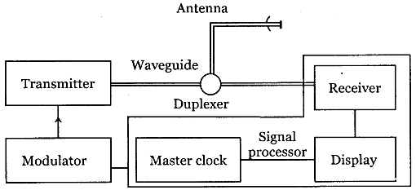

Fig**.** 2.5.1. Elements of RADAR Communication

**2.5.4 Advantages of RADAR**

The following are the advantages of RADAR:

* Radar can pierce mediums like fog, clouds, snow, and mist.
* Signals from radars can pass through isolators.
* Radar can accurately locate an object.
* The Radar will assess the target speed.
* Radar can aid in measuring an object’s distance.
* The disparity between stationary and moving targets can be determined by Radar.
* Radar signals do not require a carrying medium.
  + 1. **Limitations of RADAR**

The following are the limitations of RADAR:

* Radar requires a substantial amount of time to set a lock on an entity.
* Radar also has a wider beam size over 50 ft diameter.
* The Radar has a restricted 200 ft range.
* Numerous objects and mediums may interact in the air with Radar.
* Radar cannot discern multiple targets or come up with a solution.

**2.5.6. Applications of RADAR**

The following are the applications of RADAR:

* Radars have a wide range of usage in military operations. They are used for Naval, Ground, and Air defence purposes.
* RADARs are used to track and detect satellites and spacecraft.
* RADARs are used for safely controlling the traffic in the air. It is used to guide aircraft for proper landing and take-off during bad weather conditions.
* Law enforcement, especially highway police, has extensive use of RADARs during a pursuit to measure the speed of a vehicle.

1. **Important Questions for University Examinations**

**Short Answer Questions**

**Q1**. **What is bandwidth of a signal?**

**Answer:** Bandwidth is defined as the frequency range over which an information signal is transmitted or in other words, we can say that bandwidth is the difference between the upper and lower frequency limits of the signal.

**Q2.** **What is the difference between half duplex and full duplex communication system?**

**Answer:** Half duplex system- These systems are bidirectional, i.e. they can transmit as well as receive but not simultaneously. At a time these systems can either transmit or receive, for example a transmitter or walky talky set. Full duplex system- These are truly bidirectional systems as they allow the communication to take place in both the directions simultaneously. These systems can transmit as well as receive simultaneously, for example the telephone systems.

**Q3. What is modulation and why do we need modulation?**

**Answer:** Modulation is the process by which some characteristic of a carrier is varied in accordance with a modulating wave. Need of modulation-

* To decrease the length of transmitting and receiving antenna.
* Long distance communication is possible.
* To obtain higher value of signal to noise ratio or modulating.
* To have frequency division multiplexing where large number of signals is transmitted at different frequencies.

**Q4.** **What are the disadvantage of AM technique?**

**Answer:** The AM signal is also called as “double sideband full carrier (DCBFC)” signal. The main disadvantages of this technique are-

* Power wastage takes place.
* AM needs larger bandwidth.
* AM wave gets affected due to noise.

**Q5. Define signal. Name various types of signals.**

**Answer:** A signal, formally defined as a function of one or more variables, conveys information about the nature of a physical phenomenon. Depending on whether the dependent variable is continuous or discrete, the signals are classified as:

1. Continuous signals

2. Discrete signals

**Continues-Time Signal:** A signal x(t) is said to be a continuous time signal if it is defined for all time t. A continuous signal is specified at every value of its independent variable. For example, the temperature of a room is a continuous signal.

**Discrete-Time Signal:** A discrete time signal x[nT] has values specified only at discrete points in time. The important advantage of discrete signals is that they can be stored and processed efficiently using digital devices and fast numerical algorithms.

**Q6. Compare CDMA & GSM.**

**Answer:**

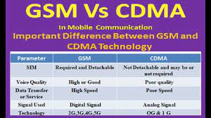

**Q8. What is called threshold detection?**

**Answer:** Radar threshold is a parameter that affects radar performance directly by causing a trade off between detection and false alarm probability. While designing radar systems, it must be set accurately in order to have reliable decisions about target detection.

**Q9. What is the range of radar communication?**

**Answer:** The two types of radar use either the sky wave or surface wave and typical ranges are 100–3500 km and up to 500 km, respectively.

**Q10. What is the principle of radar?**

**Answer:** The basic principle behind radar is that extremely short bursts of radio energy (traveling at the speed of light) are transmitted, reflected off a target and then returned as an echo.

**Long Answer Questions**

Q1. Explain the amplitude modulation and demodulation techniques with necessary diagram and equations.

Q2. Explain the basic element of communication system with necessary block diagram.

Q3. What is meant by satellite communication? Describe its block diagram and mention its applications.

Q4. Define Modulation and explain its need in communication systems.

Q5. Derive an expression for amplitude modulated wave. Also derive the relation of total power of AM waves.

Q6. With the help of a suitable block diagram, explain how radar is used in communication.

Q7. Write a short note on evolution of wireless mobile communication.

**Numerical Problems**































































